CHAPTER 7
GEOGRAPHY

GEOGRAPHICAL SETTING

The following information presents and examines existing conditions, and includes geographic setting, soils, environmental and socially sensitive areas, and land use. Portions of the information in the report are derived from a Facilities Planning Study done by Forsgren Associates in Rexburg, Idaho completed in April 1995. The study area includes the City of Lewisville, and extends about one-half mile outside the city limits in every direction. A complete copy of the study is available at the Lewisville City Offices.

TOPOGRAPHY

The City of Lewisville lies within the Snake River Plain and is one of the more uniformly leveled communities in Idaho. Part of the northern and western borders are formed by the Snake River, which makes a loop through the southeastern portion of Jefferson County. Lewisville lies southeast and east of the Snake River. The elevation of Lewisville varies from 4780 feet to 4795 feet. The general ground slope is to the west and southwest. The land is relatively flat with the exception of the Lewisville Knolls that are about one mile southwest of Lewisville, and have an elevation of 4924 feet on the north side, and 4912 feet on the south. About five miles to the northeast of Lewisville lie the Menan Buttes, with an elevation of 5053 feet on the south, and 5227 feet on the north.

GEOLOGY

The major structural feature is the Snake River Plain, which is a broad topographic depression or basin of undermined structural origin that is composed of a thick sequence of alluvium, basaltic, and silicic volcanic rock units. Topographic features on the plain include volcanic cones and vents. The area of Lewisville consists of a deep layer of basalt overlain with gravel, silt, clay, and silty loam top soils.

SOILS

The Soils Conservation Service (SCS) has classified the soils in Jefferson County as part of a recently published soil survey. All soils in and around the city are classified according to the SCS map shown in Table 7-1.

Page 7-1

Table 7-1 - SCS Soil Types and Characteristics for the City of Lewisville
TYPE | SCS CODE | PERMEABILITY | DEPTH ** | TEXTURE
Annis Silty Loam* | 2 | moderately slow | 0-12"  12-21"  21-49"  49-60" | silty clay loam, silt loam  silt loam  silty clay  silt loam
Bannock Loam | 7 | moderate | 0-11"  11-31"  31-60" | loam  sandy loam  gravelly sand
Blackfoot Silt Loam  (Drained)* | 16 | moderate to  very high | 0-10"  10-60" | silt loam  loam, silty clay loam, silt loam,  fine sandy loam
Hayeston Sandy Loam | 39 | moderately rapid | 0-23"  23-28"  28-60" | sandy loam  very gravelly sandy loam  sand and gravel
Heiseton Sandy Loam | 43 | moderately rapid | 0-9"  9-20"  20-40"  40-60" | loam  loamy sand  fine sandy loam  sand and gravel
Heiseton Loam | 44 | moderately rapid | 0-7"  7-18"  18-36"  36-60"+ | loam  loamy sand  fine sandy loam  sand and gravel
Labenzo Silt Loam | 53 | moderate to  very high | N/A | N/A
*Most Dominant **Information from SCS

Page 7-2

JEFFERSON COUNTY IDAHO GENERAL SOIL MAP
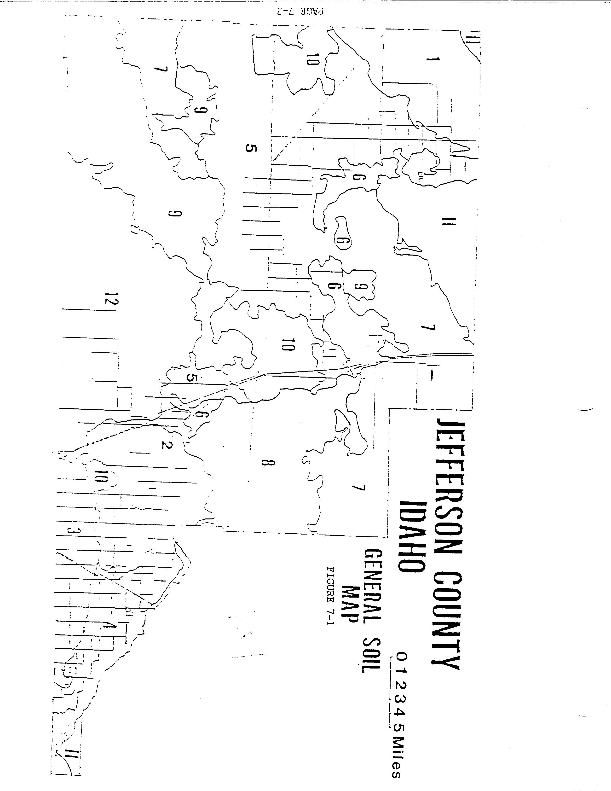
PAGE 7-3

FIGURE 7-1 -- GENERAL SOIL MAP LEGEND

NEARLY LEVEL, WELL AND MODERATELY WELL DRAINED SOILS

1. Whiteknob-Bereniceton-Lidy association: Nearly level, well drained, shallow over gravel to very deep, medium and moderately coarse textured soils on alluvial fans.

2. Annis-Blackfoot association: Nearly level, moderately well drained, very deep, medium and moderately fine textured soils on river terraces.

3. Bannock-Zeric Torrifluvent-Bockston association: Nearly level, well drained, shallow to deep over gravel, medium textured soils on river terraces.

4. Hayeston-Heiston-Blackfoot association: Nearly level, moderately well and well drained, moderately deep and deep over gravel, moderately coarse and moderate textured soils on river terraces.

5. Terreton association: Nearly level, well drained, very deep, fine textured soils on old lake beds.

NEARLY LEVEL, POORLY AND VERY POORLY DRAINED SOILS

6. Levelton-Medano association: Nearly level, poorly and very poorly drained, very deep, fine and moderately coarse textured soils on old lake beds.

NEARLY LEVEL TO ROLLING, SELL AND SOMEWHAT EXCESSIVELY DRAINED SOILS ON BASALT PLAINS

7. Grassy Butte-Matheson-Diston association: Nearly level to rolling, well and somewhat excessively drained, very deep and moderately deep, coarse and moderately coarse textured soils on basalt plains.

8. Modkin-Bondranch-rock outcrop associations: Nearly level to rolling, well drained, shallow and moderately deep, moderately coarse textured soils on basalt plains.

9. Aecet-Bereniceton-Rock outcrop association: Nearly level to gently rolling, well drained, moderately deep and very deep soils on basalt plains.

10. Matheson-Malm-Bereniceton association: Nearly level to gently rolling, well drained, moderately deep and very deep, medium and moderately coarse textured soils on basalt plains.
Page 7-3A

CLIMATE

Jefferson County has a mid-latitude, semi-arid climate. The summers are warm and dry. The county, located mostly on the Snake River Plain, is one of the most uniformly level counties in Idaho. Therefore, the area climate is relatively uniform.

The daily range in temperature is greatest in the summer, and the range is considerably smaller in the winter. The mean temperature ranges from 16.1 degrees F in January to 68.3 degrees F in July. The growing season averages 119 days but may vary from 80 to 160 days.

The annual precipitation averages about eight inches. The greatest precipitation usually occurs in May and June. The wettest and windiest months occur during the spring, and warming is gradual. Freezing temperatures at night are common through most of April. A sharp decrease in precipitation occurs during the summer, when most of the rainfall comes in the form of local showers.

Records show that 39% of the total precipitation is received in the spring; 22% in the summer; 20% in the fall; and, 19% in the winter. The wettest month is usually June with an average of 1.25 inches, and the driest month is February with an average of 0.41 inches.

Annual evaporation from an open pan averages 40 to 55 inches, of which 80% or more occurs from May through October. Mean annual evaporation from lakes and reservoirs is estimated at 30 to 40 inches.

Page 7-4

FIGURE 7-2
MEAN ANNUAL PRECIPITATION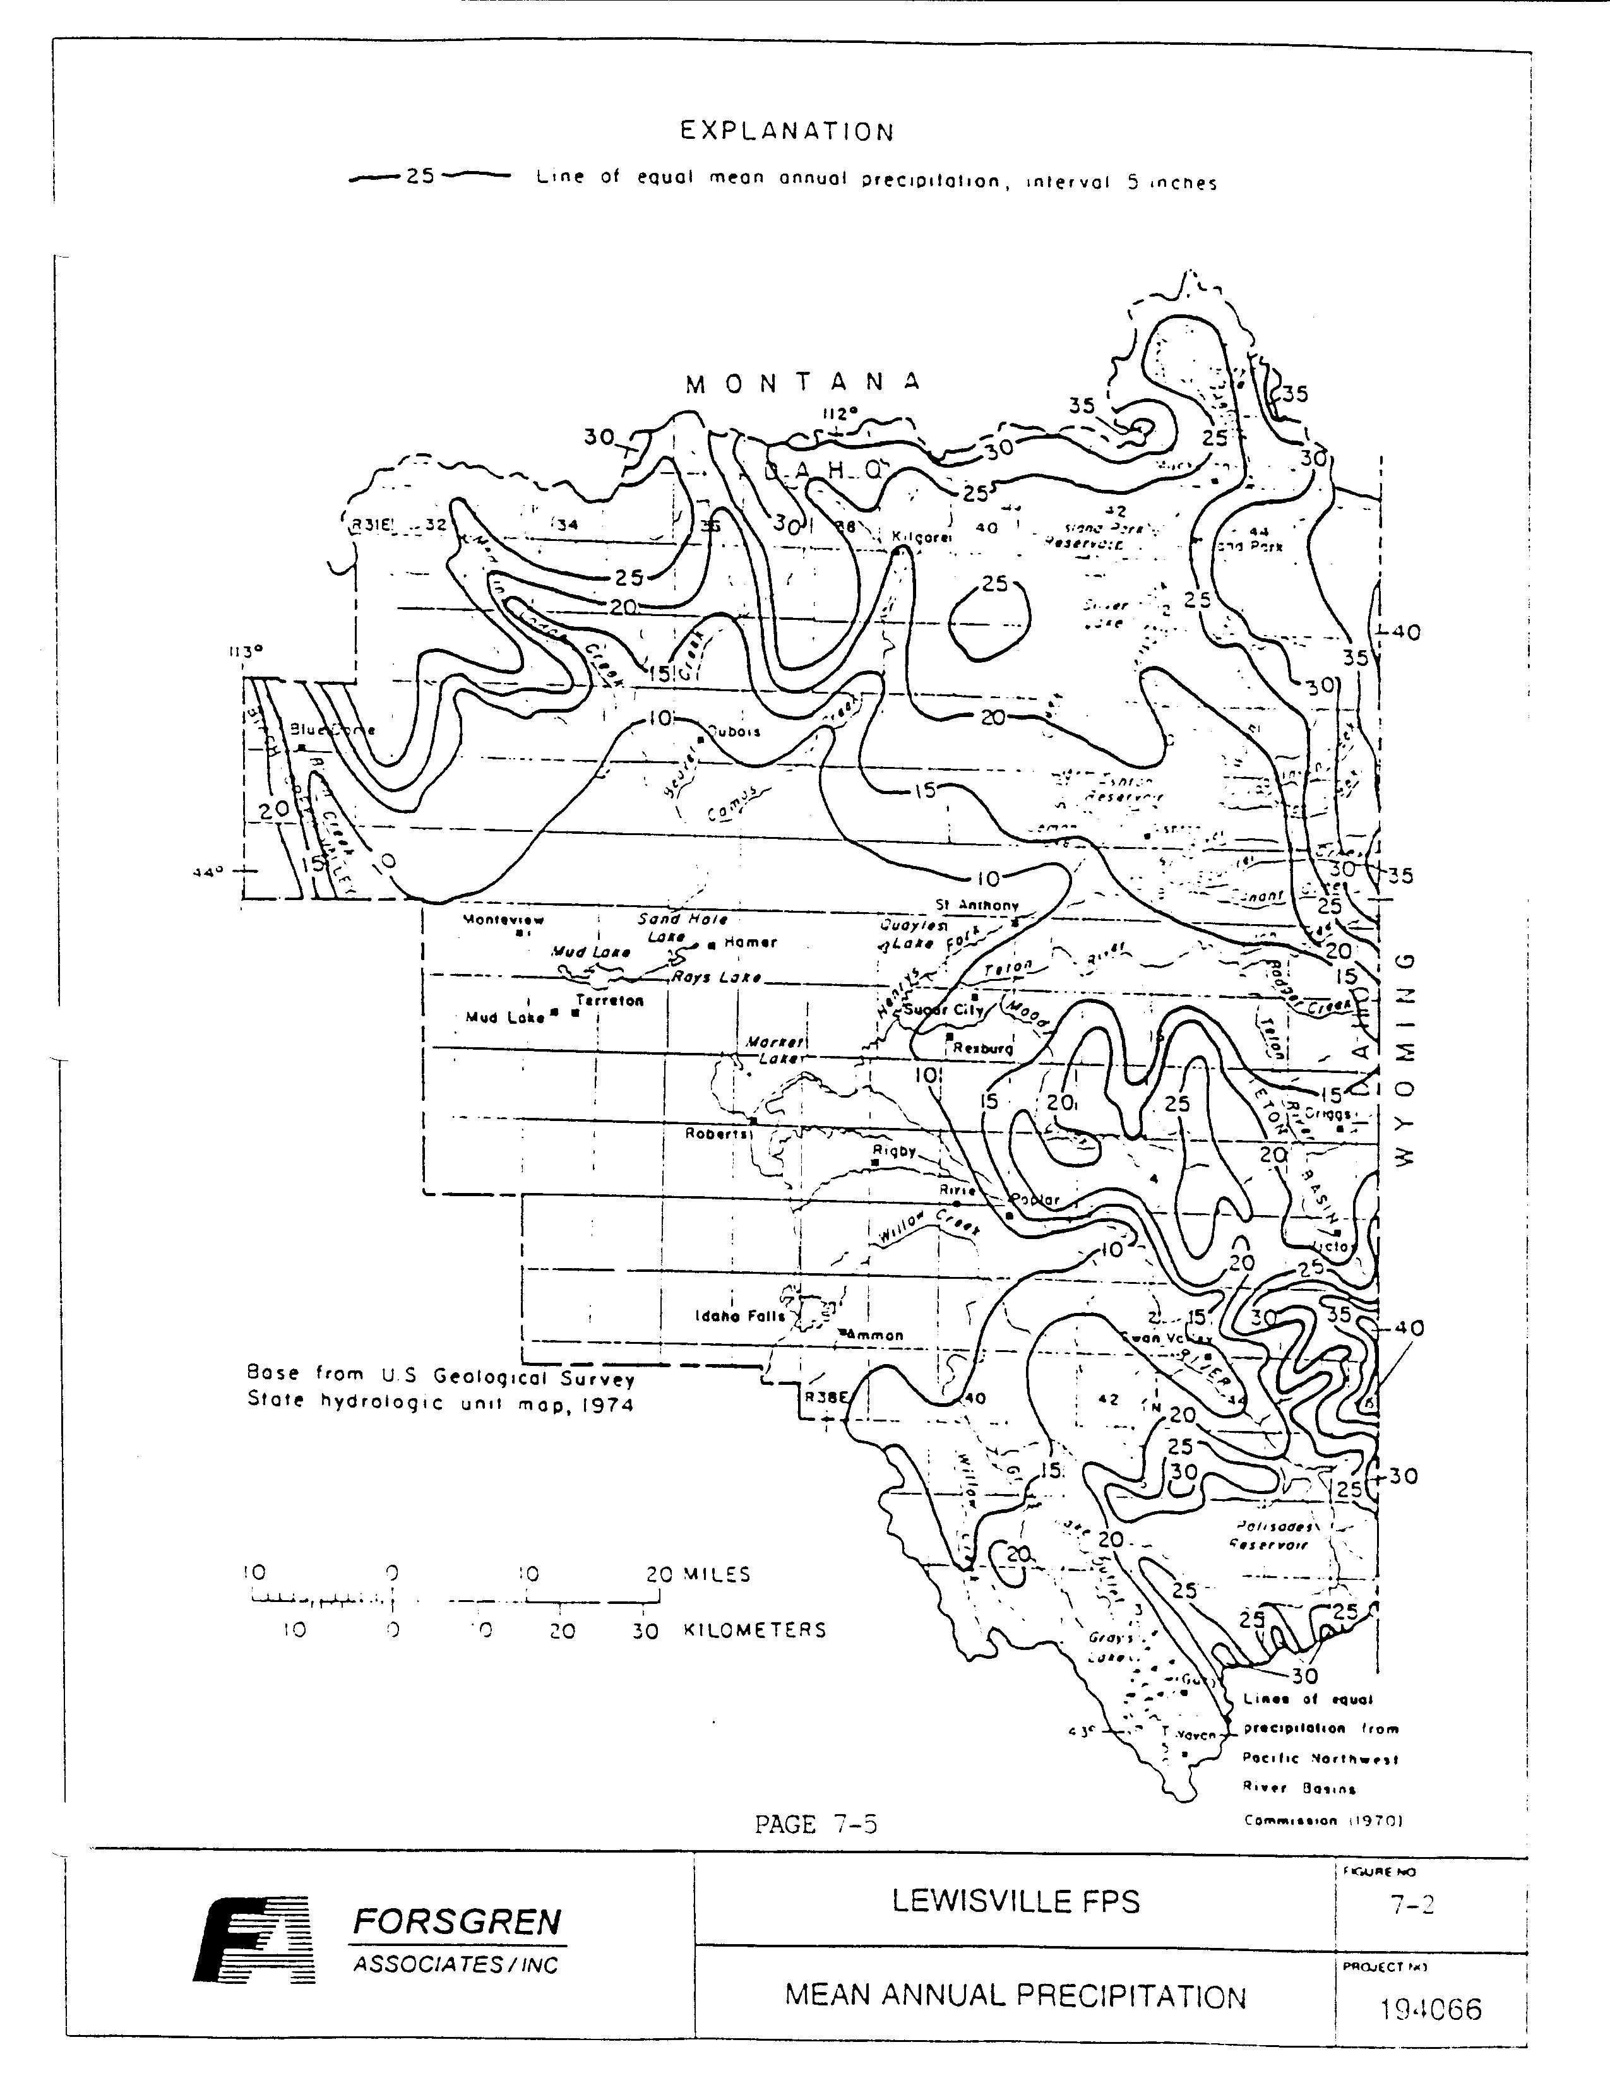Page 7-5

LAND USE

The existing land use within Lewisville includes single-family residential, industrial, commercial, park and open space, public and semi-public, and agricultural uses. The predominate use of the land within the city is single-family residential, with some commercial, industrial, public, and agricultural use covering the remaining areas. Agricultural lands surround the city and add a rural suburban setting.

Although the city has adopted various ordinances defining the placement of mobile and manufactured homes, building standards, health safety, control of animals and weeds, excess water on public sidewalks and streets, and refuse dumping, a formal land use plan has not been adopted. Population trends show a slow stable growth of single-family homes with a small retail commercial base. It is anticipated that land use will not change dramatically within the community or the surrounding area in the near future. The agricultural land use typical of the Snake River Valley will most likely remain the same for the Lewisville area.

Page 7-6

FIGURE 7-3
LAND USE MAP
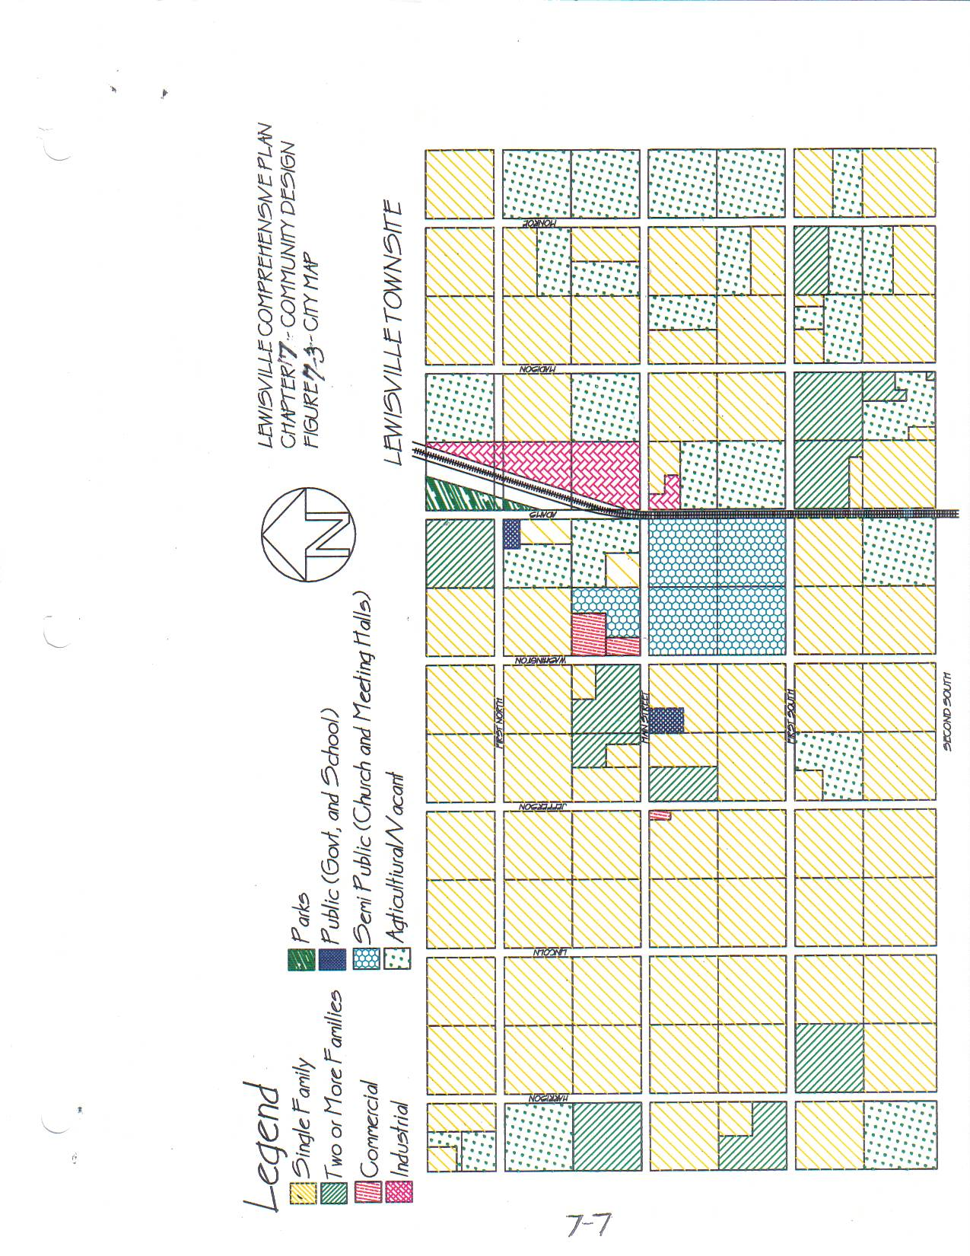

Page 7-7

GROUND WATER AND HYDROLOGIC FEATURES

The Snake River runs adjacent to the study area and is one of the major rivers in Idaho and the Northwest. Surface waters within the area all drain into the river. The Lewisville study area overlies the Snake River aquifer, which is one of the largest and most productive aquifers in the world. Most communities in Eastern Idaho obtain their domestic water supply from this aquifer. The water is of high quality and generally meets drinking water standards without treatment, except occasional chlorination. The Snake River Plain aquifer has been designated as a “sole source aquifer’.

Groundwater movement in the Eastern Snake River basin is generally in the direction of the hydraulic-gradient from places of high hydraulic head to places of low head, and from areas of recharged to areas of discharge. Figure 7-4 shows the direction and movement of groundwater and is based on potentiometric surface contour maps obtained from the “Reconnaissance of Groundwater Quality of Eastern Snake River Basin, Idaho” (US Geological Survey - 1983). In the Plains sub-area, water in alluvium and basalt rock units moves generally southwestward. The groundwater within the City of Lewisville will vary between five and twelve feet below the ground surface. Figure 7-5 shows testing locations for groundwater depth, performed when groundwater is projected to be at its highest point during the irrigation season of August. This figure also shows the locations of test sites with their associated water levels.

The sub-water within the Lewisville area is historically high, winter levels being about 10 to 12 feet deep, and summer levels of five to six feet. There are a few low lying areas within the city that allow sub-water to surface, where it stands in pastures and canal ways.

Page 7-8

FIGURE 7-4
DIRECTION AND MOVEMENT OF GROUNDWATER
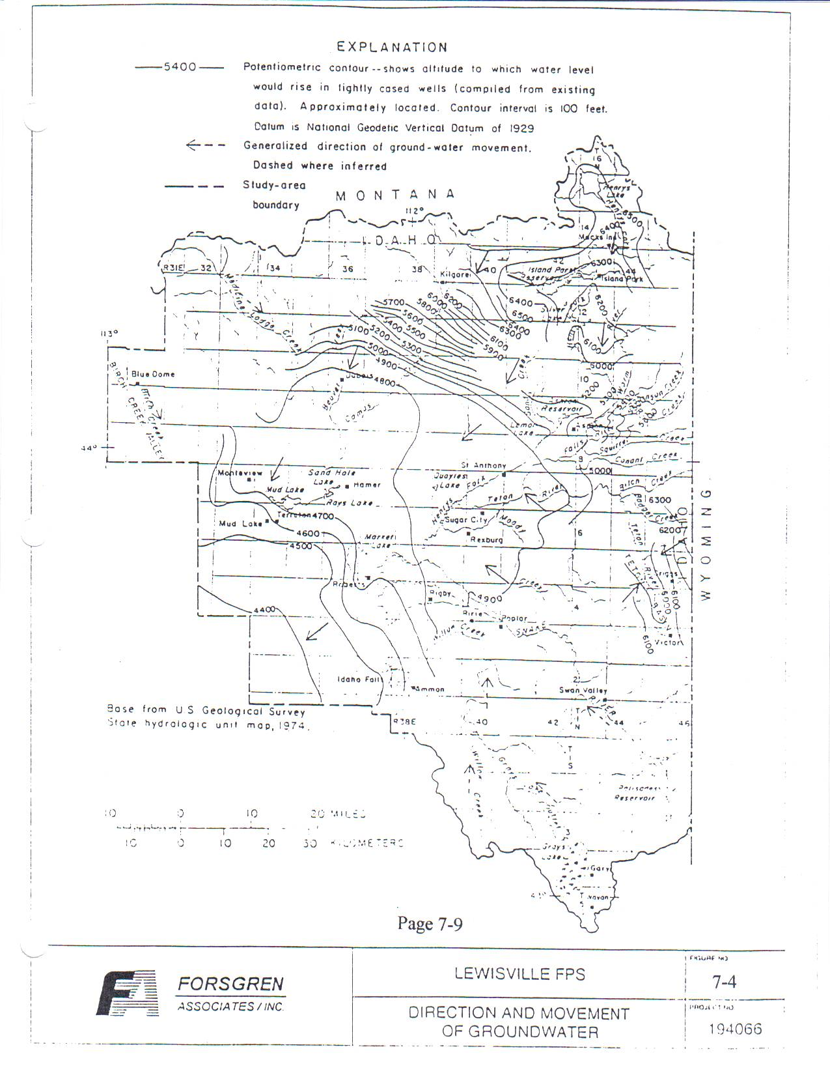
Page 7-9

FIGURE 7-5
SOIL TEST LOCATIONS SHOWING GROUNDWATER DEPTH
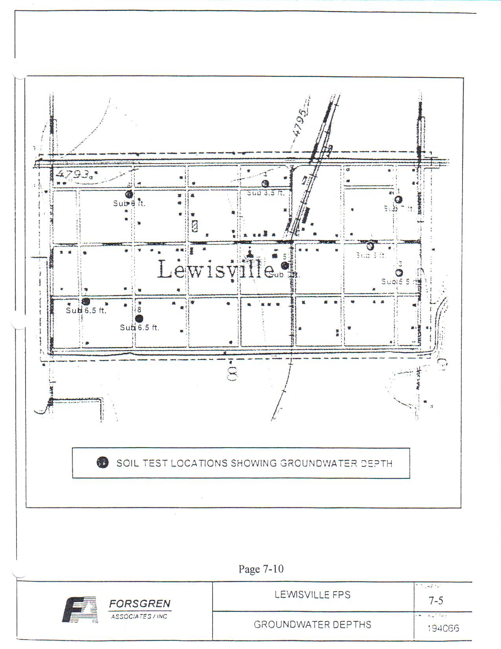
Page 7-10

EXISTING AND PROJECTED WATER CHARACTERISTICS

The existing culinary water facility within the City of Lewisville consists of individual well systems. The existing wells range in depth from 40 to 200 feet deep. Due to the individual wells that supply a large area, concern for groundwater and surface water is of major importance.

Groundwater quality characteristics, such as chemical constituents, physical properties, and bacterial concentrations, determine the suitability of water for use. Principal consumptive demands for groundwater in the study area are for domestic, irrigation, industrial, public supply, and livestock uses. In relation to human needs, water quality criteria determined in 1976 by the US Environmental Protection Agency (EPA), designates maximum levels of some water quality characteristics that, when not exceeded, will not harm water users.

In contrast, drinking water regulations which may use criteria as a basis, describe legally established mandatory (primary) and recommended (secondary) limits for chemical constituents, physical properties, and bacterial concentrations. These will be used as guidelines for this report. It must be noted that federal drinking water regulations legally apply only to public water supplies, not supplies for private use. Regulation limits do, however, provide a comparative base for all water quality discussions.

Some of the factors that effect the chemical, physical, and biological characteristics of groundwater can be linked to the influences of human activity. Those of concern are the effect of individual sub-surface wastewater disposal systems and the possible effect they could be having on the groundwater within the Lewisville area.

For cesspools, septic tanks, and drain fields those characteristic contaminants typically are the dissolved solids particulate, chloride, sulfate, nitrogen compounds, phosphates, and bacteria.

Page 7-11

As part of this study, culinary groundwater wells were monitored throughout town wherein 20 individual sites were sampled on three separate occasions. The first sampling took place in June of 1994, the second sampling in August of 1994, and third in October 1994. The same sites were used for all three samplings. During the first series of tests, sites 3, 12, 14, and 18 were found to have a presence of total coliform. Site 18 also showed fecal coliform.

In reference to nitrate and nitrite (as N), the samples ranged from a low of 0.25 mg/l to a high of 3.3 mg/l. The limits as set by the Safe Drinking Water Act for nitrates is 10 mg/l. Therefore, all samples tested had concentrations less than the maximum allowable level

In the second and third series of sampling, total coliform was found at site 8. This site also showed presence of fecal coliform. The minimum concentration for nitrate (as N) was 0.38 mg/l with a maximum of 3.45 mg/l and all nitrite concentrations were non-detectable. Site 10 showed a presence of total coliform on the third series of tests.

In reference to the nitrate, there is a definite effect that can be correlated with the groundwater movement within the City of Lewisville. The downstream side of the groundwater nitrate were higher than those on the upstream side. However, it is difficult to determine whether these nitrate compounds are coming from septic tank and drain field systems or from another source of nitrate, possibly by way of fertilizers. Given this, all nitrate concentrations are well below the maximum contaminant level set by the EPA.

Page 7-12

FIGURE 7-2
LEWISVILLE GROUNDWATER MONITORING

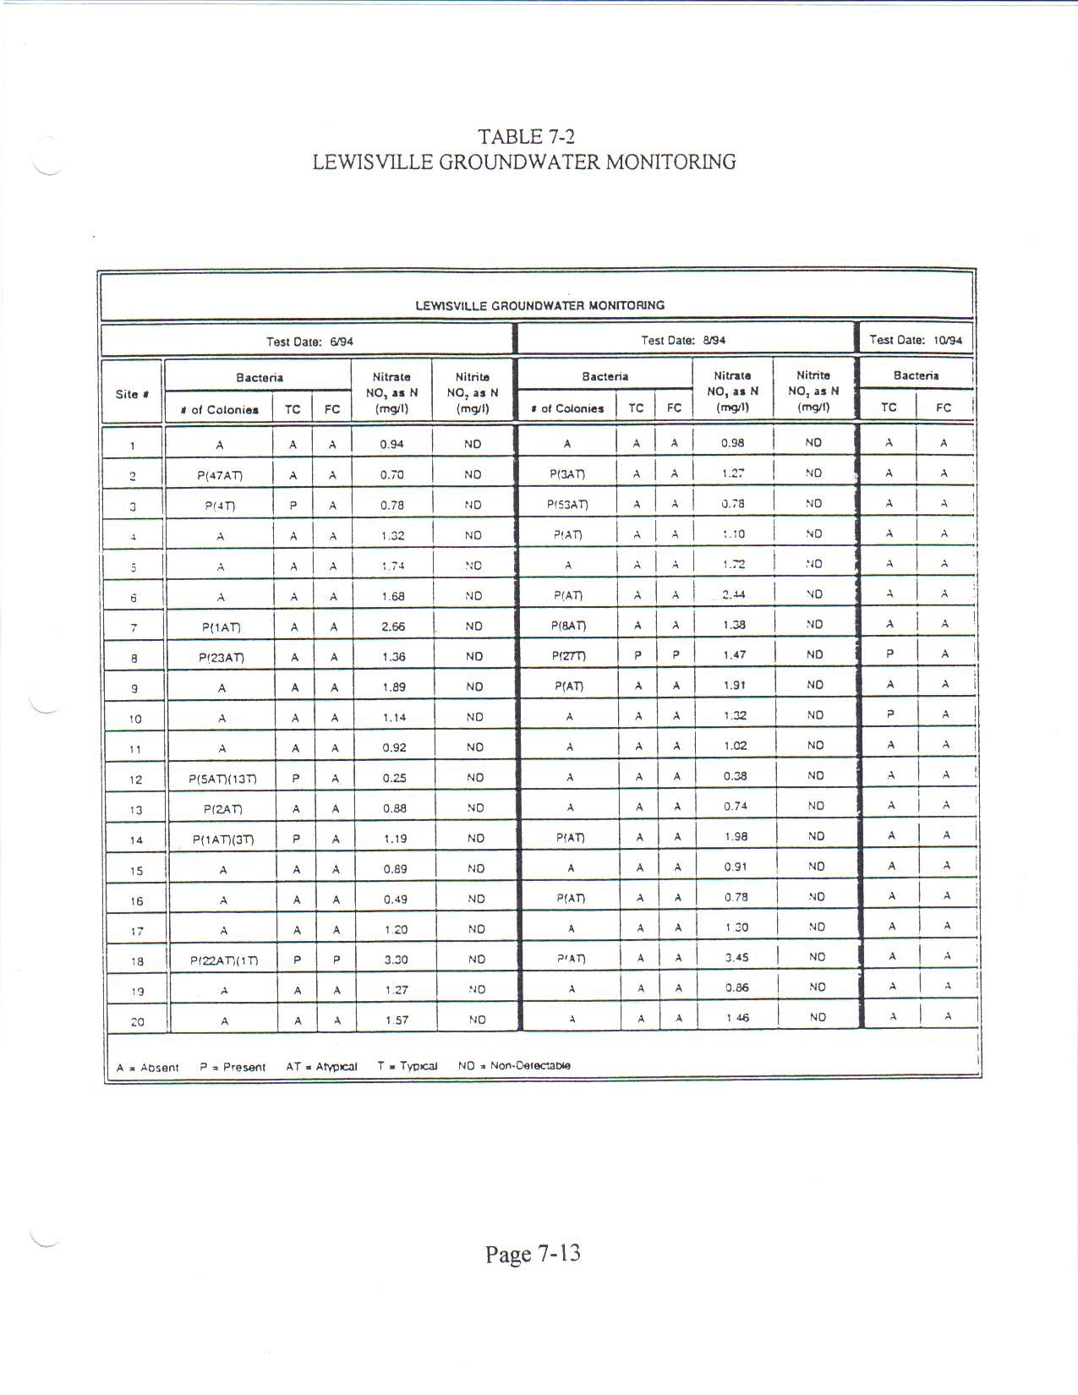

Page 7-13

FIGURE 7-6
GROUNDWATER SAMPLE SITES
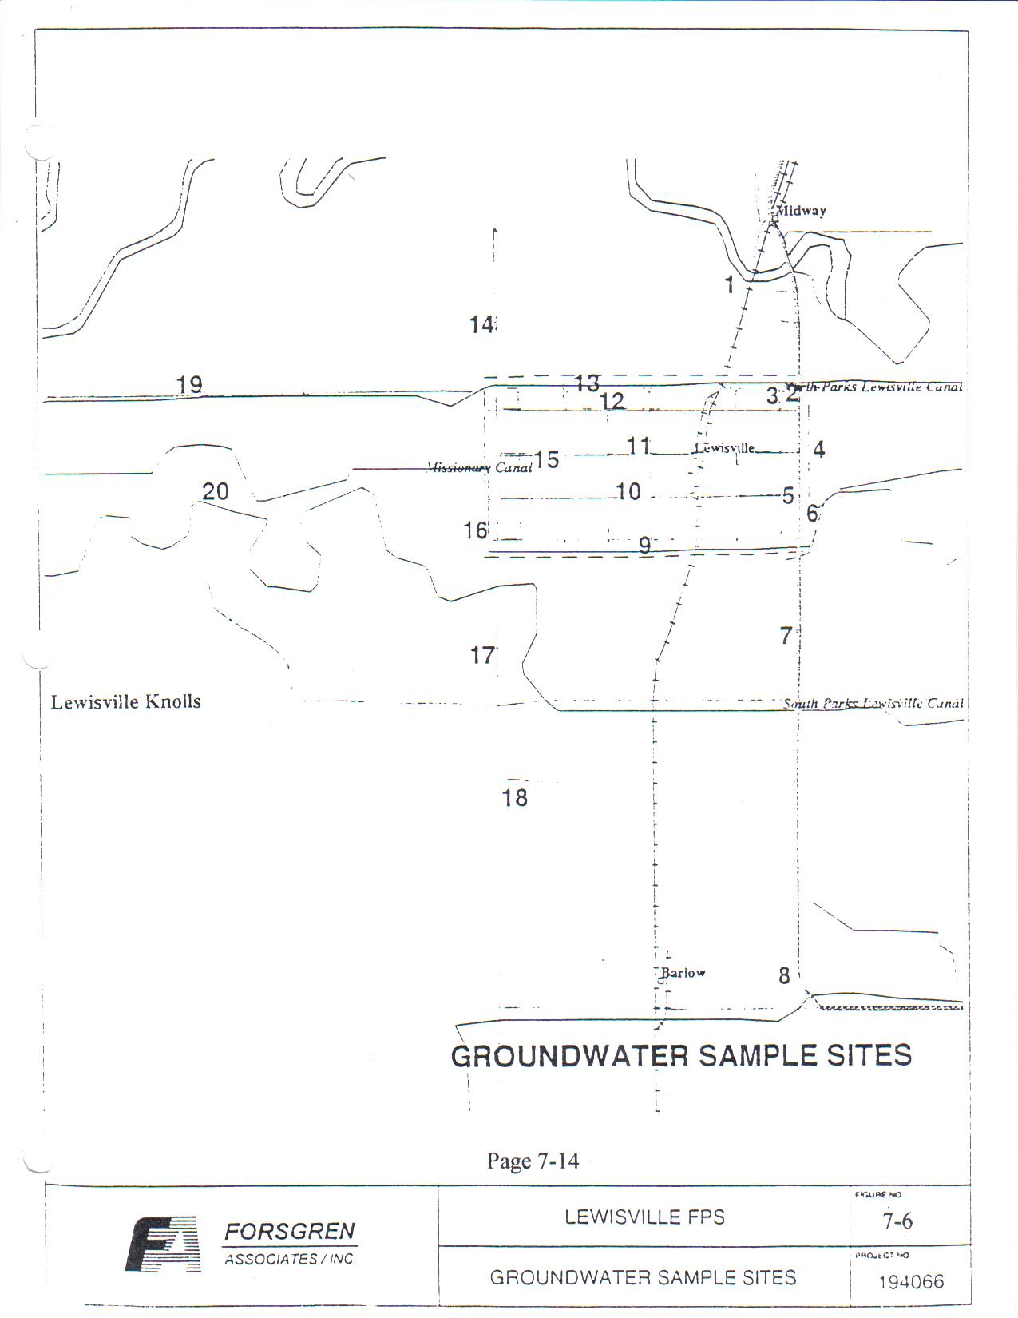
Page 7-14

WASTEWATER

All homes or occupied buildings in Lewisville have individual cesspool or septic tank with a drain field or seepage pit. The exact number of each system has not been determined.

The older systems are cesspools. It is believed that only a few of these are still existing in the city. Most of the newer septic systems are built of concrete, hold about 1000 gallons, and are located beneath the ground surface.

Effluent from the septic tanks are generally disposed of by drain fields. Soil absorption drain fields have a perforated non-metallic pipe located in a trench filled with gravel filtering material. The trenches are specified to be a certain length and width to meet the absorption area requirements set by the Idaho Department of Health and Welfare. Absorption trenches are backfilled with soil. There are minimum distances that all components of the septic tank and soil absorption system must be from each other and other water wells, buildings, property lines, water supply lines, streams, ponds, ditches, and canals.

The septic tank and soil percolation system used for wastewater treatment and disposal provide a form of physical and biological treatment. Wastewater from the home or building enters the septic tank through a non-metallic pipe. Scum, grease, and settleable solids are removed from the liquid by flotation and gravity separation, and these solids are retained in the septic tank. The retained solids are digested by bacterial action and are partially liquified.

If solids build up too quickly in the septic tank, frequent pumping may be required. Septic tanks should be pumped every three to five years, according to Idaho Department of Health and Welfare and the EPA. Solids may be collected for ten to fifteen years before they are cleaned out. The solids are called “septage”, which is usually pumped from the septic tanks into trucks. Pumping more frequently than every three years is an indication the system is too small for the home or business it serves.

The septic tank effluent flows to either a soil absorption drain field or a seepage pit. It is necessary to have three feet of unsaturated soils in an absorption drain field for proper treatment of wastewater. The unsaturated flow of effluent is established by a biological layer or mat that develops between the trench filtering material, usually gravel, and the soil. The mat is composed of micro-organisms from the soil and effluent. The micro-organisms attach themselves to the soil particles and each other, forming a net along the sides and bottom of the septic tank. The micro-organisms feed on suspended and dissolved solids, including bacteria.

Page 7-15

If a septic tank is not pumped regularly, solids will build up in the tank and will eventually be carried into the drain field. There the solids can disrupt the system.

When the system functions properly, the tank effluent receives proper treatment as it passes through the soil absorption system. The treated effluent then flows through the sub-surface geological features to the groundwater.

In areas where the soils are too granular for a proper mat to develop in the absorption trenches, the water from the drain field or seepage pit drains rapidly to the underlying groundwater without receiving proper treatment. In areas where lava rock is near the surface, fractures in the lava rock allow this inadequately treated wastewater from drain fields to move immediately downward from the drain fields or seepage pits into the underlying groundwater.

The area within the City of Lewisville typically has had a soil type that has been adequate for septic tank and drain field systems. However, in some cases, not all septic tank drain field systems can meet the three foot minimum affected soil depth due to the high groundwater levels. This is enough to cause concern for groundwater quality within the city.

A survey of city residents was done to determine the condition of septic systems in the city. Of the 125 residences and businesses surveyed, 82 responses were obtained, a 66% response. All of the respondents indicated they used a cesspool or septic tank system.

The average house in Lewisville is about 45 years old. Individual disposal systems range in age from very new to over 60 years. Many of the older systems are cesspools. Because cesspools dispose of wastewater through a relatively small volume of soil, they have a higher contamination potential.

The survey documented frequent pumping, system replacement, and general complaints to establish the reliability and maintenance history of the individual systems. According to the survey, 28% of those responding pumped the septic system more than once every three years; 38% had replaced the septic tank, drain field, or cesspool; 20% had replaced at least parts of the system within the past ten years; and 31% were currently experiencing problems with their septic system. Wastewater design manuals concur that pumping septic systems more often than every three to five years is an indication that the system is too small for the place it serves. The fact that 31% of those surveyed are presently experiencing problems or dissatisfaction with their septic system is a major concern and is an indication that some other wastewater disposal practice should be considered, according to the Forsgren study.

The present over-all density of homes in the city is 0.35 per acre. Forecasted population growth estimates overall density of 0.42 dwellings per acre by 2014. Experiences with communities with soil types similar to Lewisville have shown that when localized housing densities are below one house per acre, septic tanks generally function with few problems. Densities above that number will see an increase in groundwater contamination.

Page 7-16

The Forsgren study concludes that anticipated housing densities within the city are not a major concern currently, but should be monitored, particularly if any significant impact were to develop within the city. The housing density and population growth trends are based on 1990 US Census statistics. The 1994 population, as reported by US Commerce Department, was 671, more than the 520 forecasted by the Forsgren study to occur in 2014. This would indicate the need to reassess the study recommendations because of a significant, unexpected population increase.

Further recommendations include surveying households to determine whether current income levels would qualify the city for funding to construct a city wastewater system; that the city build a wastewater system to avoid future contamination of water; that the city involve constituents in planning for the project; and, that the city actively seek funding for the project.

IRRIGATION WATER

Yards and small pastures or garden spots within the city limits are watered from April 1 to October 31 by irrigation water from Parks and Lewisville Canal Company, or by water from private wells. The canal company, chartered in 1888, only four years after the town’s settlement, administers a system of canals and ditches that carries water from the Snake River to land within the town site and neighboring agricultural lands. In 1893, the flooding river cut through it’s north channel, reducing the water in the Dry Bed, forcing neighboring canal systems to form the Little Feeder Company. In 1894-1895 the Great Feeder Canal system was built on the Snake River east of Lewisville near Heise. When the river changed course, the Little Feeder System was unable to control the river flow. Lewisville farmers were forced to buy stock in the Great Feeder system. Lewisville and Parks Canal Company continues to own stock in the Great Feeder Canal, as well as the Palisades Dam.

Parks and Lewisville Canal Company officials do not anticipate any changes in the canal system
currently, (1997), or in the near future.

Sources: Facilities Planning Study, Forsgren Associates, 1995
Soil Conservation Service
US Geological Survey
1990 US Census
Parks and Lewisville Canal Company
Lewisville Centennial Book

Page 7-17

